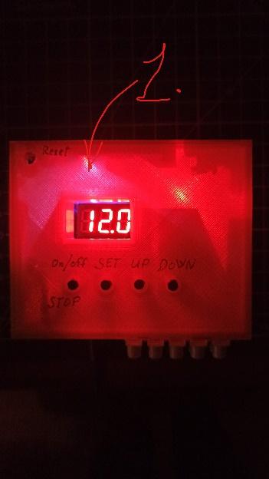LED1 is Blue and not blink? – You are in Config Portal Mode!!!

1. 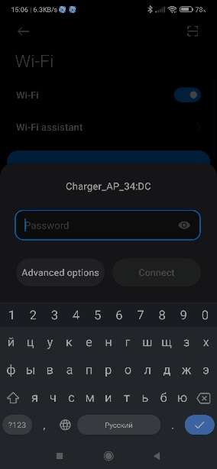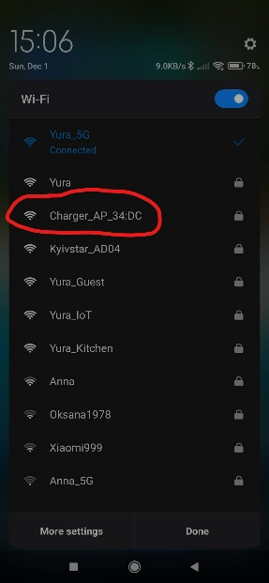Expand WiFi Networks 2. Find Charger_AP_*:* Network. 3. Enter: password – it is a Charger_AP wifi pass. 4. Tap to Connected to Charger_AP….

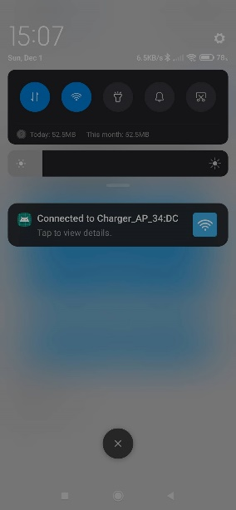

5. Configure WiFi 6. Choose your Home WiFi Network and enter password. 7. Leave all other parameters as they are.

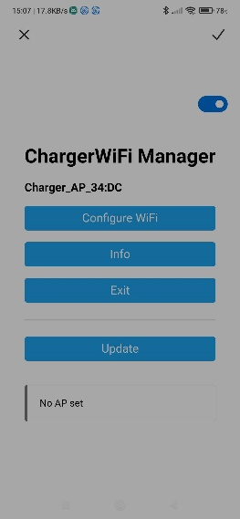

Telegram BOT

1. Send message /start or /register

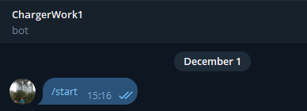

1. 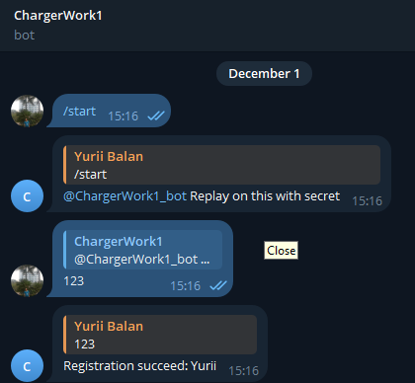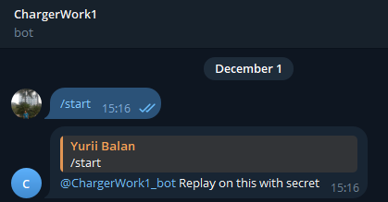IMPORTANT: Replay on message that bot answered (use Telegram Bot Security parameter from Config Portal to replay and finish channel registration)